**AREESHA MANSOOR (02-131202-046)**

**BSE(5-A)**

**OEL 1**

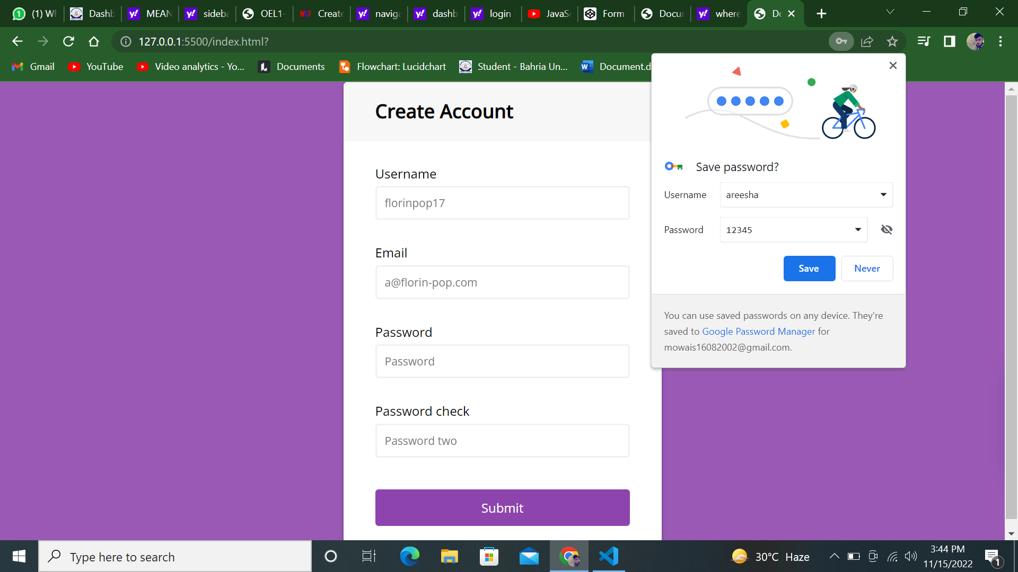

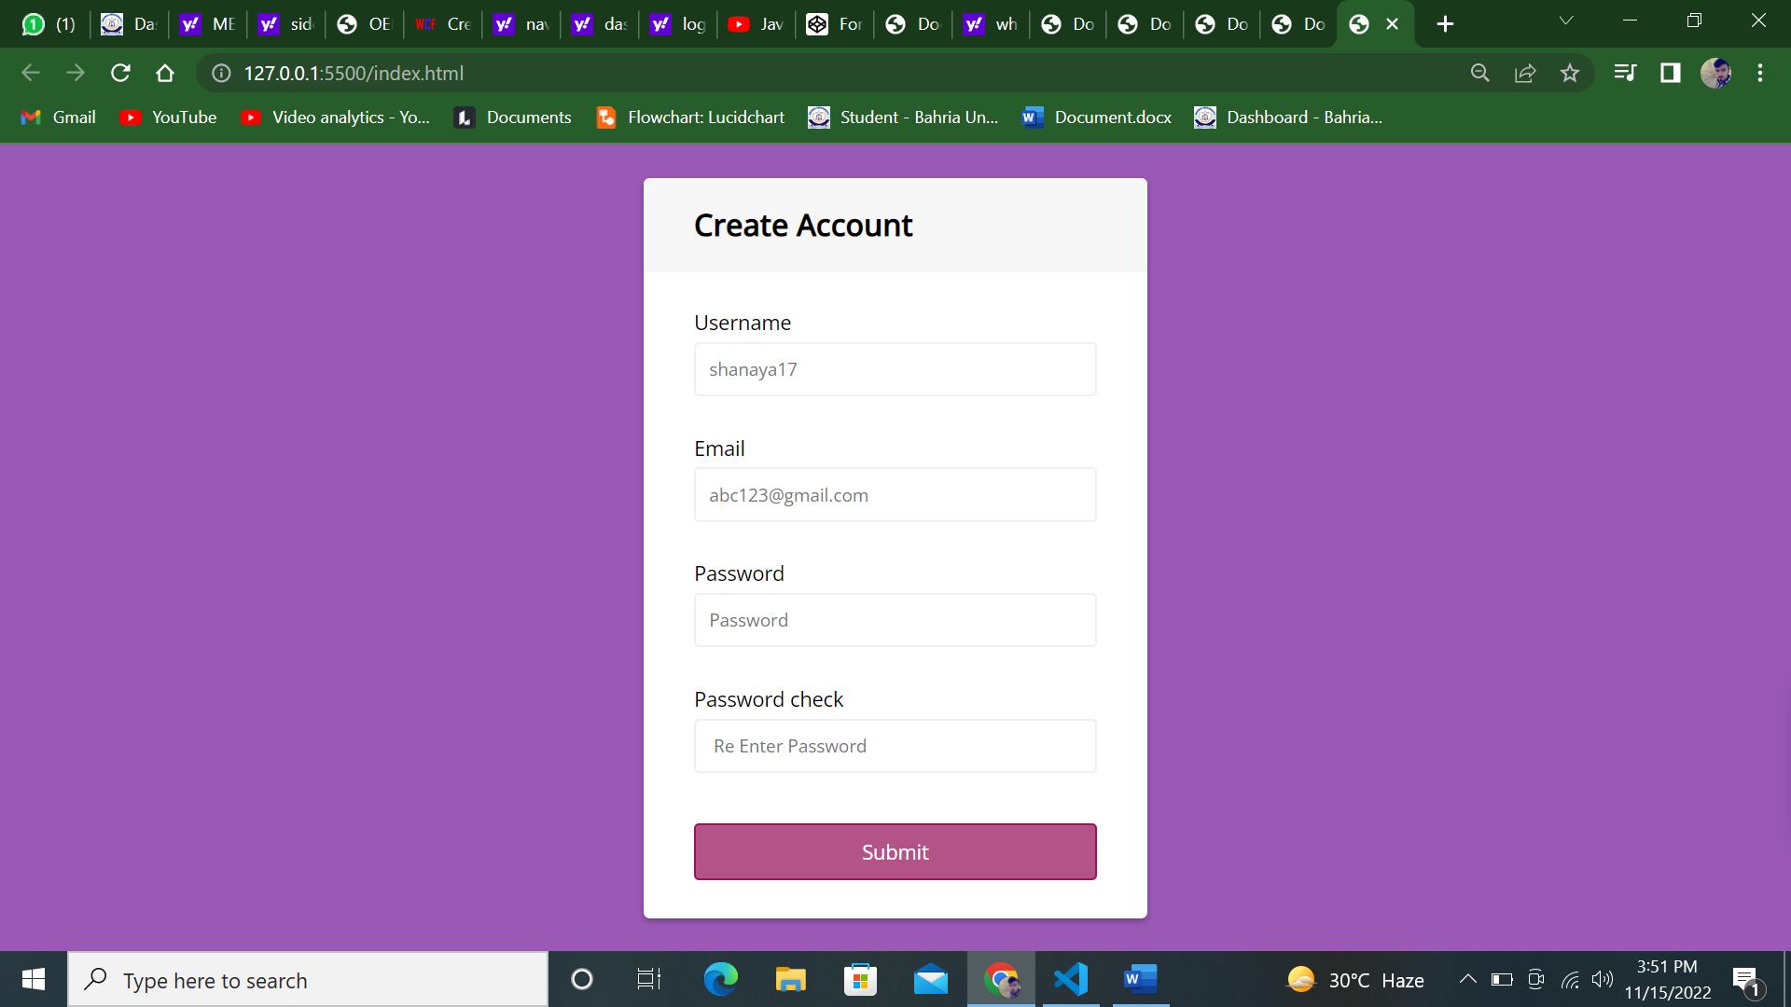

 <link rel="stylesheet" href="index.css" type="text/css">

    <script src="index.js"></script>

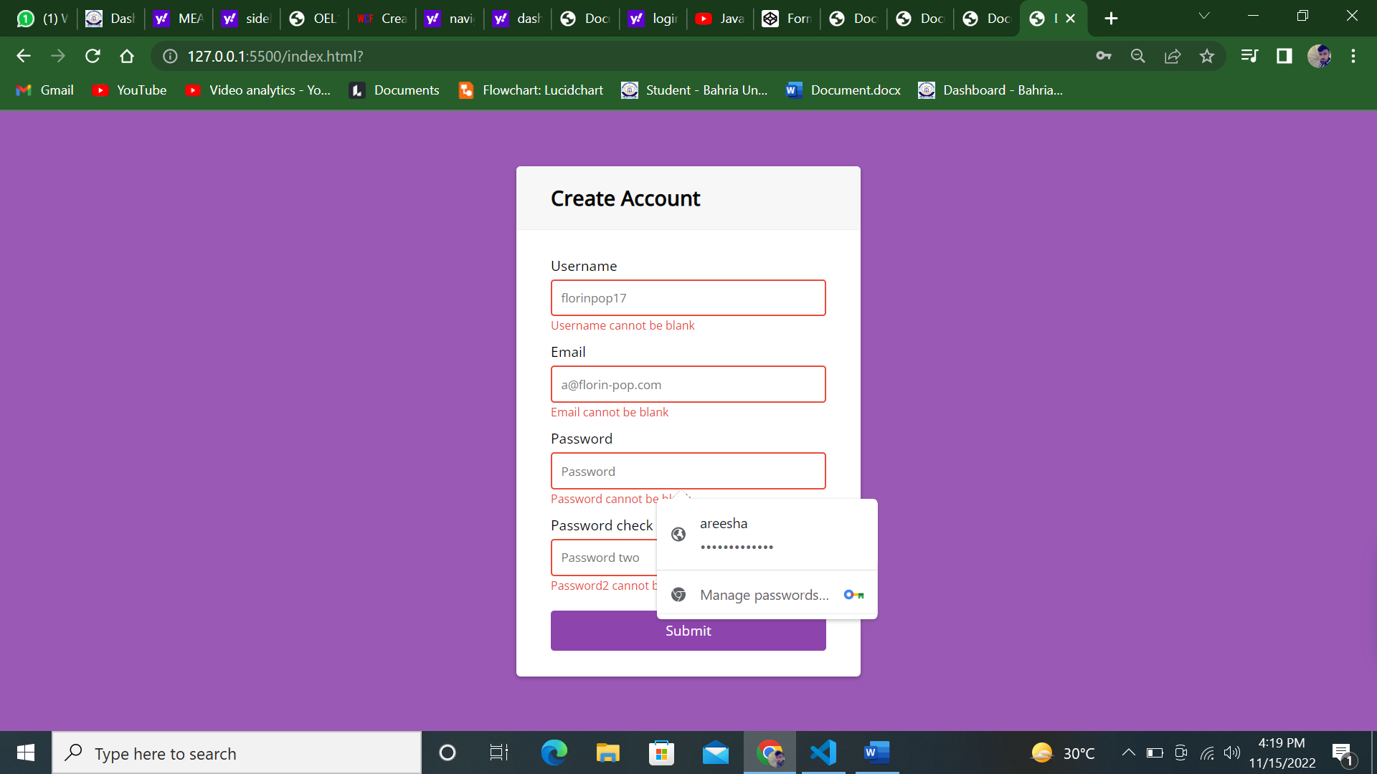

…………………………………….

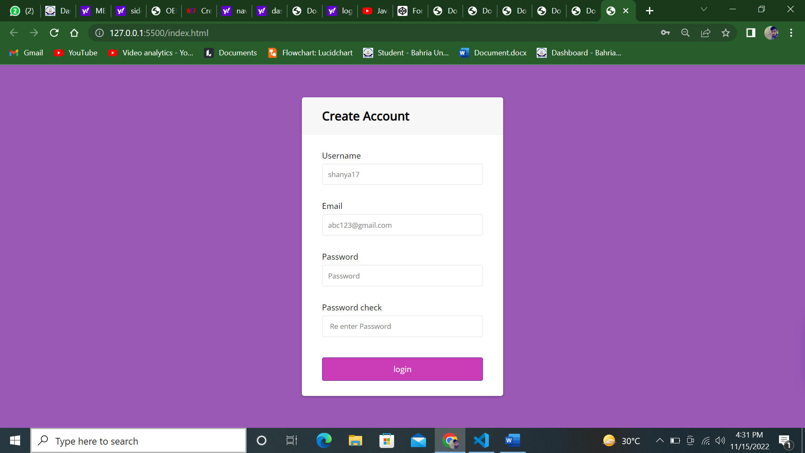

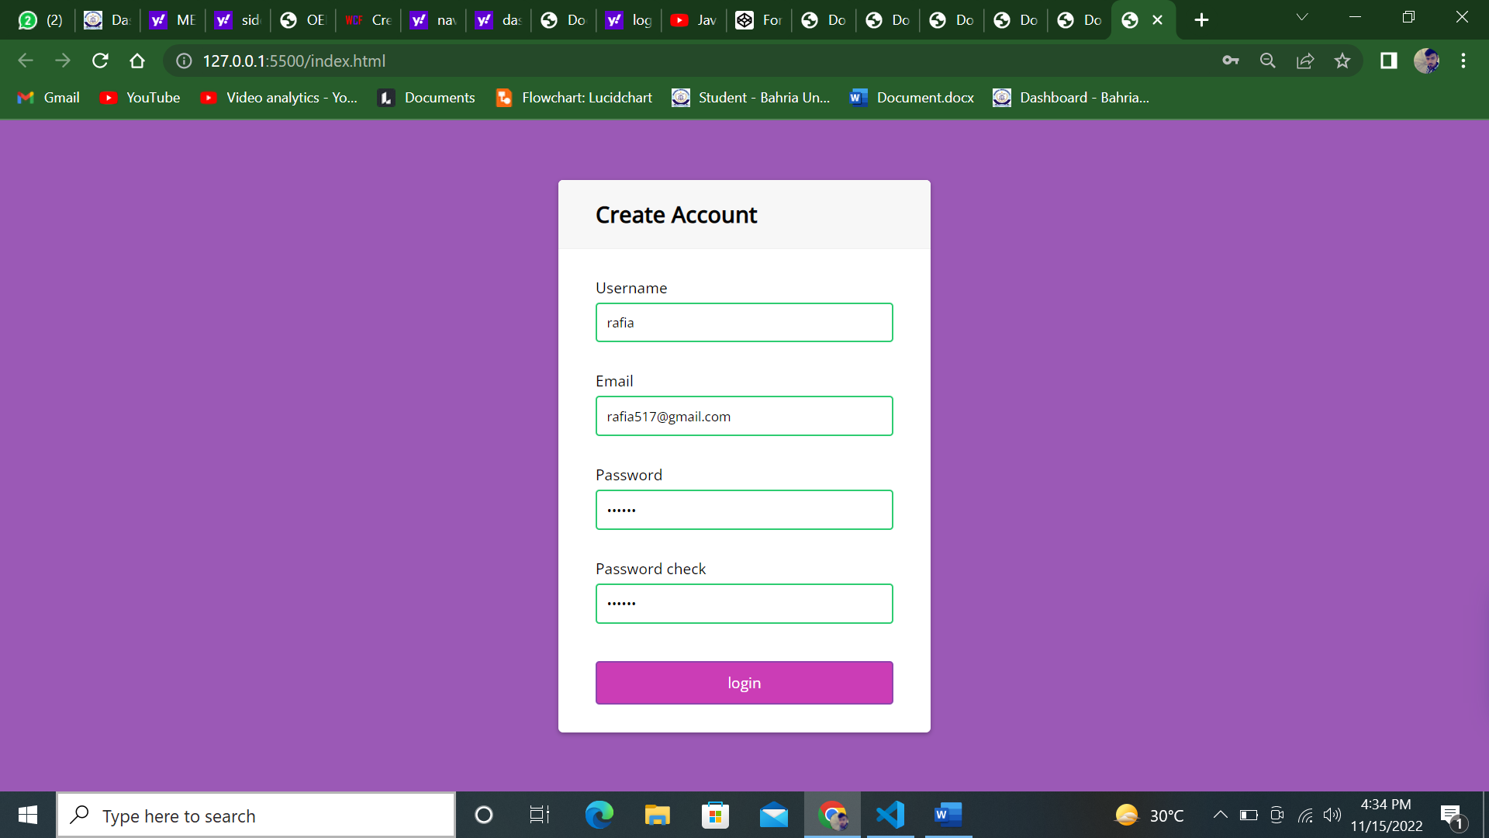

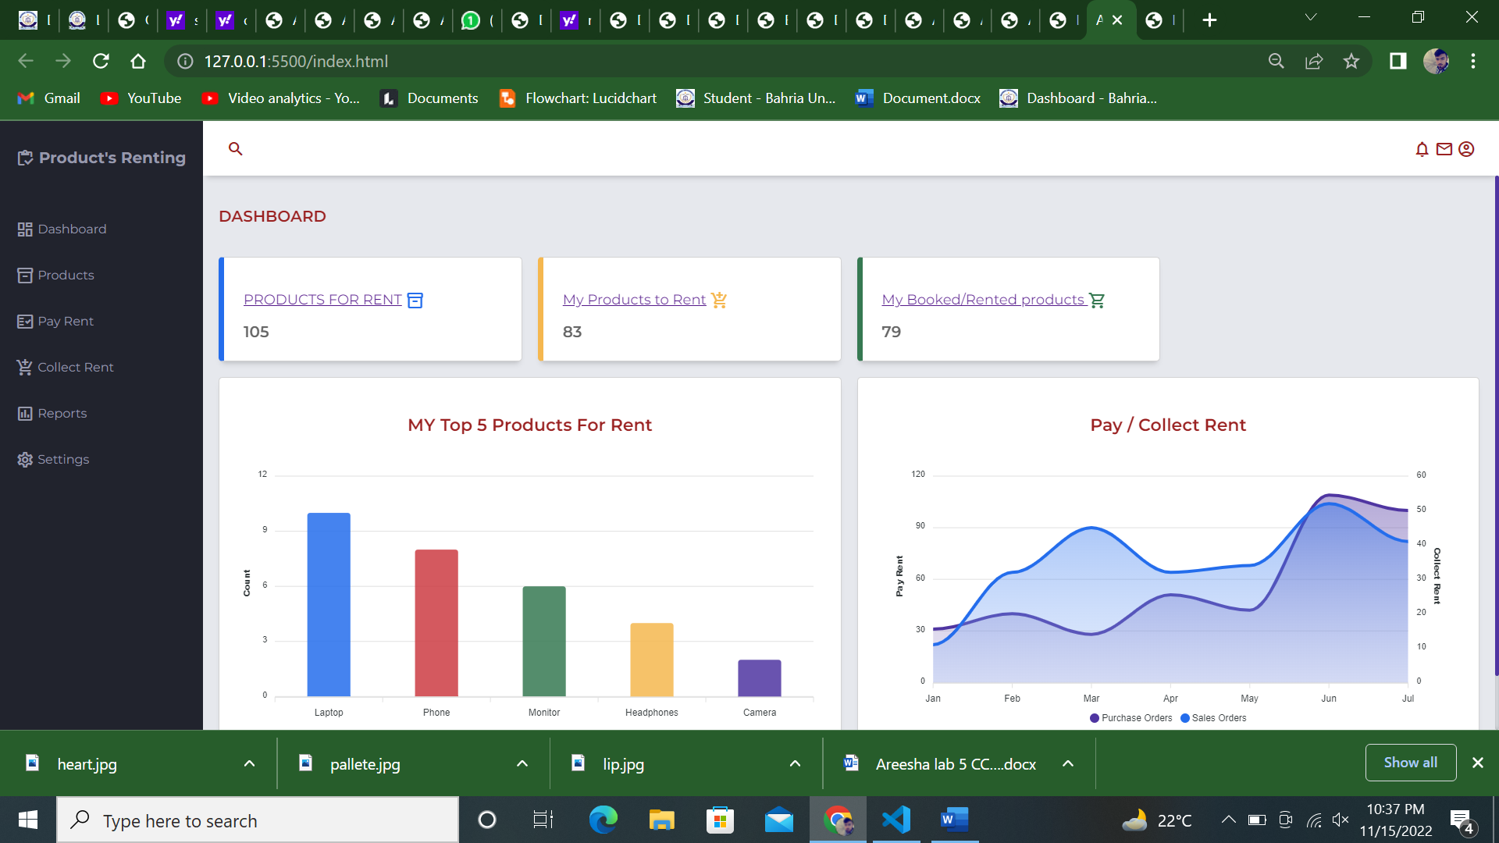

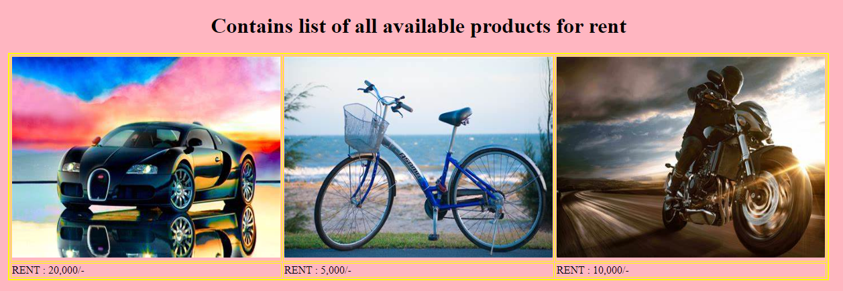

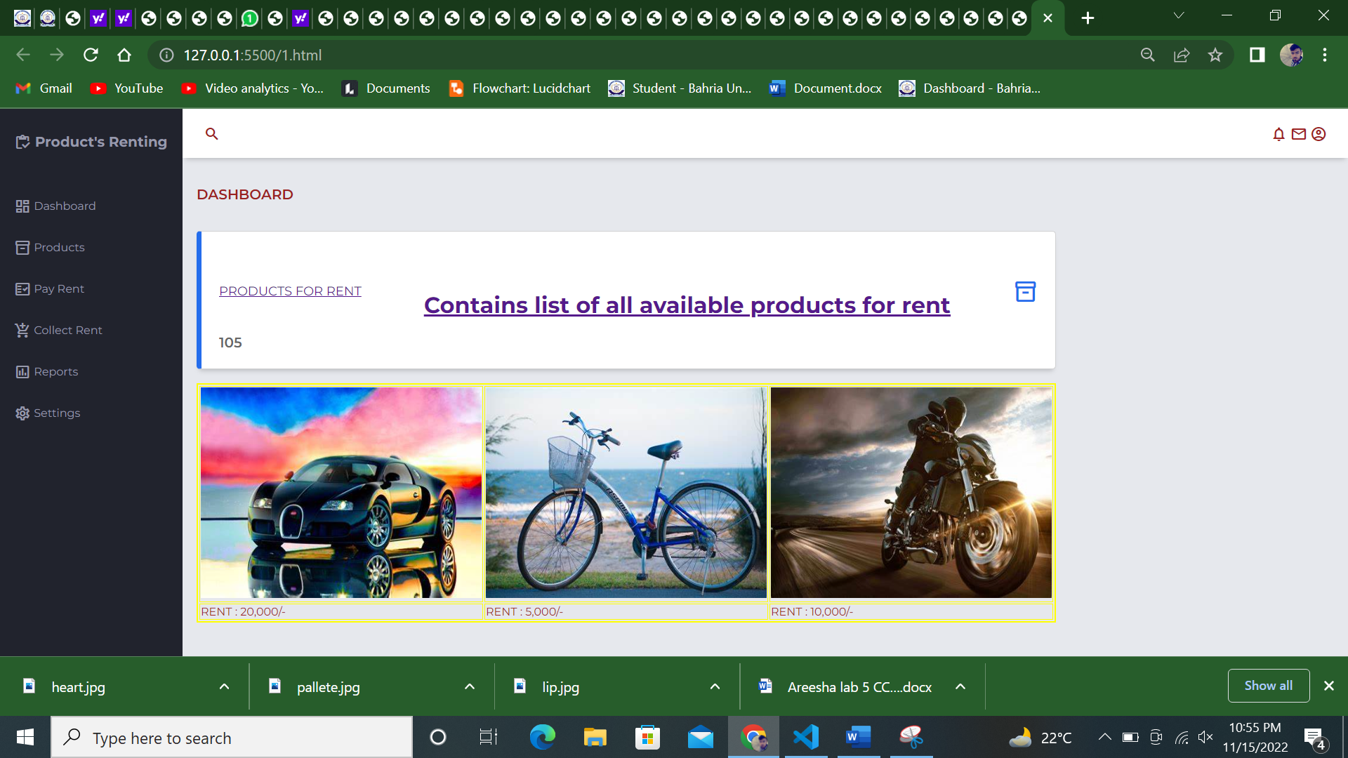

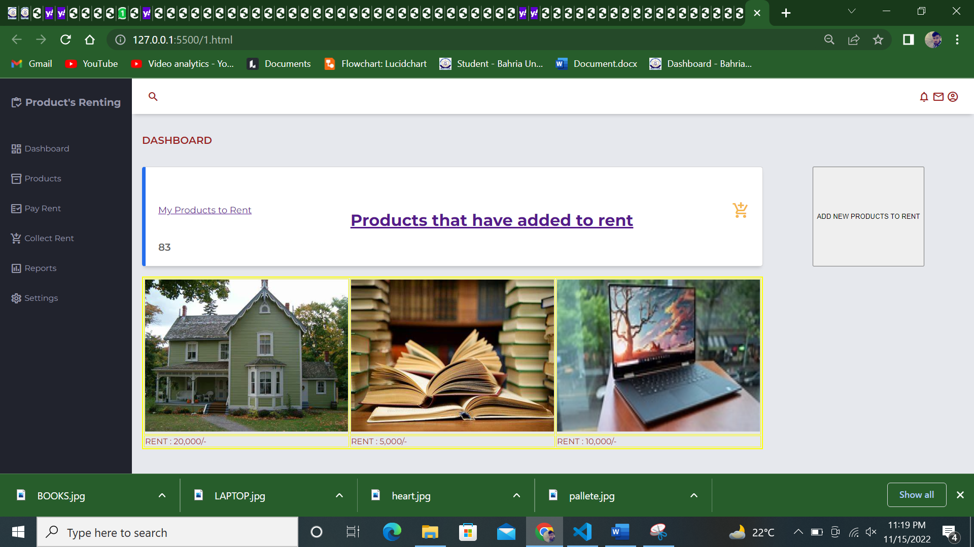

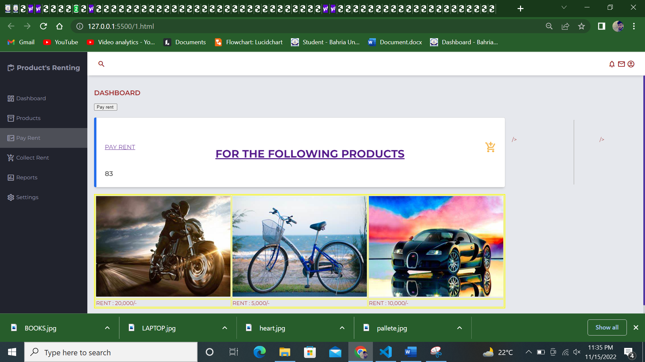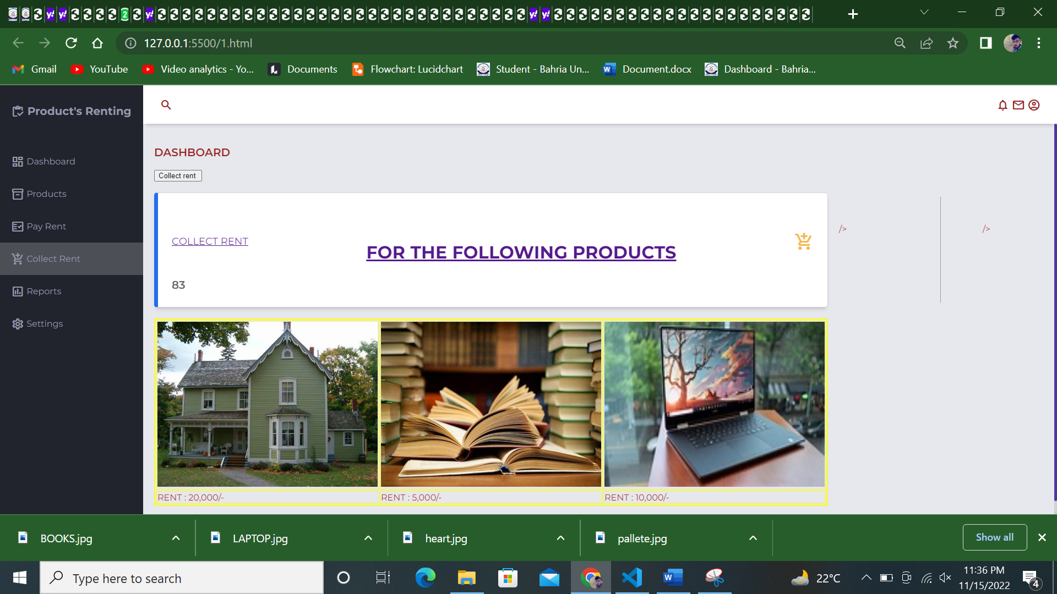

SECOND INTERFACE:

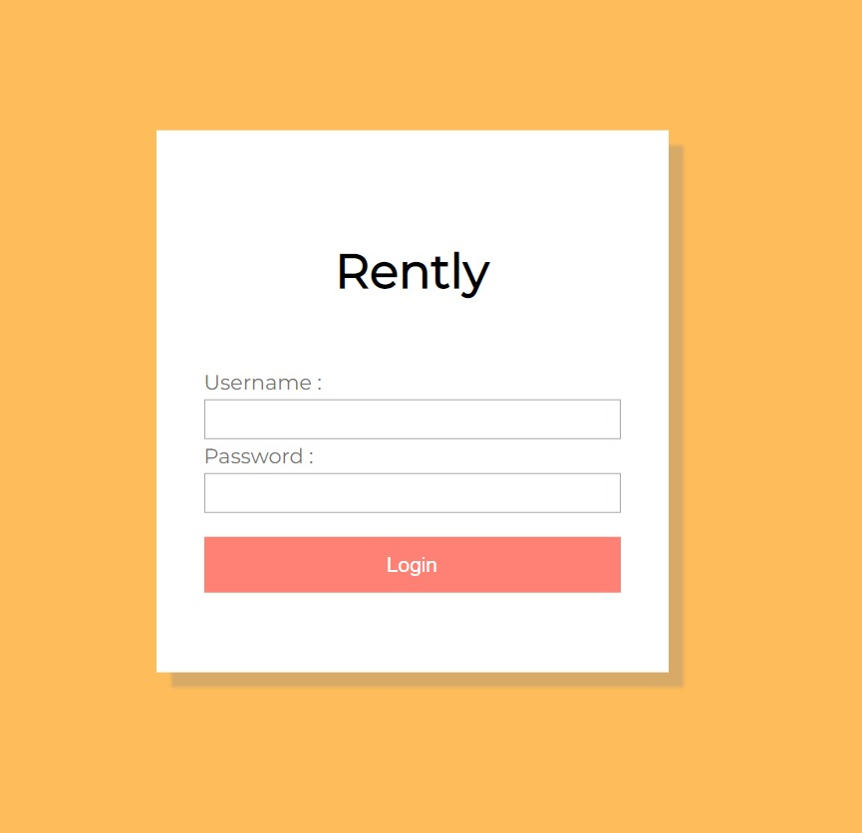

…………………………………………..

<!DOCTYPE html>

<html lang="en">

  <head>

    <meta charset="utf-8">

    <meta name="viewport" content="width=device-width,initial-scale=1.0">

    <title>Admin Dashboard</title>

    <!-- Montserrat Font -->

    <link href="https://fonts.googleapis.com/css2?family=Montserrat:wght@100;200;300;400;500;600;700;800;900&display=swap" rel="stylesheet">

    <!-- Material Icons -->

    <link href="https://fonts.googleapis.com/icon?family=Material+Icons+Outlined" rel="stylesheet">

    <!-- Custom CSS -->

    <link rel="stylesheet" href="styles.css">

  </head>

  <body>

    <!-- <tr><th width="20%"> <font color="white" size="5"> <a href= "tab1.html"> tab 1</a></font></th></tr> -->

    <div class="grid-container">

      <!-- Header -->

      <header class="header">

        <div class="menu-icon" onclick="openSidebar()">

          <span class="material-icons-outlined">menu</span>

        </div>

        <div class="header-left">

          <span class="material-icons-outlined">search</span>

        </div>

        <div class="header-right">

          <span class="material-icons-outlined">notifications</span>

          <span class="material-icons-outlined">email</span>

          <span class="material-icons-outlined">account_circle</span>

        </div>

      </header>

      <!-- End Header -->

      <!-- Sidebar -->

      <aside id="sidebar">

        <div class="sidebar-title">

          <div class="sidebar-brand">

            <span class="material-icons-outlined">inventory</span> Product's Renting

          </div>

          <span class="material-icons-outlined" onclick="closeSidebar()">close</span>

        </div>

        <ul class="sidebar-list">

          <li class="sidebar-list-item">

            <span class="material-icons-outlined">dashboard</span> Dashboard

          </li>

          <li class="sidebar-list-item">

            <span class="material-icons-outlined">inventory_2</span> Products

          </li>

          <li class="sidebar-list-item">

            <span class="material-icons-outlined">fact_check</span> Pay Rent

          </li>

          <li class="sidebar-list-item">

            <span class="material-icons-outlined">add_shopping_cart</span> Collect Rent

          </li>

          <!-- <li class="sidebar-list-item">

            <span class="material-icons-outlined">shopping_cart</span> Sales Orders

          </li> -->

          <li class="sidebar-list-item">

            <span class="material-icons-outlined">poll</span> Reports

          </li>

          <li class="sidebar-list-item">

            <span class="material-icons-outlined">settings</span> Settings

          </li>

        </ul>

      </aside>

      <!-- End Sidebar -->

      <!-- Main -->

      <main class="main-container">

        <div class="main-title">

          <p class="font-weight-bold">DASHBOARD</p>

        </div>

        <div class="main-cards">

            <div class="card">

                <div class="card-inner">

                  <p class="text-primary"><a href= "1.html">My Products to Rent   <h1 align ="center"><br/>  Products that have added to

                    rent</h1></a></a>

                  <span class="material-icons-outlined text-orange">add_shopping_cart</span>

                </div>

                <span class="text-primary font-weight-bold">83</span>

              </div>

              <br/>

         <br/>

<style>

.footer{

background-color: rgb(204, 113, 113);

 height: 50px;

}

</style>

<input type="submit" value="ADD NEW PRODUCTS TO RENT" >

</head>

<body bgcolor="#FFB6C1 ">

    <!-- <hr/> -->

<!-- <h1 align ="center"><br/>                                                   </h1> <br/> -->

<table border="2" bordercolor="yellow" width= "1200 " height="300" align="center">

<tr>

<td width="400" height="300"><img src="p1.jpg"width="400" height="300"></td>

<td width="400" height="300"><img src="BOOKS.jpg"width="400" height="300"></td>

 <td width="400" height="300"><img src="LAPTOP.jpg"width="400" height="300"></td>

</tr>

<tr>

    <br/>

<td>RENT : 20,000/-</td>

<td>RENT : 5,000/-</td>

<td>RENT : 10,000/-</td>

</tr>

</table>

</body>

</html>

………….

<!DOCTYPE html>

<html lang="en">

  <head>

    <meta charset="utf-8">

    <meta name="viewport" content="width=device-width,initial-scale=1.0">

    <title>Admin Dashboard</title>

    <!-- Montserrat Font -->

    <link href="https://fonts.googleapis.com/css2?family=Montserrat:wght@100;200;300;400;500;600;700;800;900&display=swap" rel="stylesheet">

    <!-- Material Icons -->

    <link href="https://fonts.googleapis.com/icon?family=Material+Icons+Outlined" rel="stylesheet">

    <!-- Custom CSS -->

    <link rel="stylesheet" href="styles.css">

  </head>

  <body>

    <!-- <tr><th width="20%"> <font color="white" size="5"> <a href= "tab1.html"> tab 1</a></font></th></tr> -->

    <div class="grid-container">

      <!-- Header -->

      <header class="header">

        <div class="menu-icon" onclick="openSidebar()">

          <span class="material-icons-outlined">menu</span>

        </div>

        <div class="header-left">

          <span class="material-icons-outlined">search</span>

        </div>

        <div class="header-right">

          <span class="material-icons-outlined">notifications</span>

          <span class="material-icons-outlined">email</span>

          <span class="material-icons-outlined">account_circle</span>

        </div>

      </header>

      <!-- End Header -->

      <!-- Sidebar -->

      <aside id="sidebar">

        <div class="sidebar-title">

          <div class="sidebar-brand">

            <span class="material-icons-outlined">inventory</span> Product's Renting

          </div>

          <span class="material-icons-outlined" onclick="closeSidebar()">close</span>

        </div>

        <ul class="sidebar-list">

          <li class="sidebar-list-item">

            <span class="material-icons-outlined">dashboard</span> Dashboard

          </li>

          <li class="sidebar-list-item">

            <span class="material-icons-outlined">inventory_2</span> Products

          </li>

          <li class="sidebar-list-item">

            <span class="material-icons-outlined">fact_check</span> Pay Rent

          </li>

          <li class="sidebar-list-item">

            <span class="material-icons-outlined">add_shopping_cart</span> Collect Rent

          </li>

          <!-- <li class="sidebar-list-item">

            <span class="material-icons-outlined">shopping_cart</span> Sales Orders

          </li> -->

          <li class="sidebar-list-item">

            <span class="material-icons-outlined">poll</span> Reports

          </li>

          <li class="sidebar-list-item">

            <span class="material-icons-outlined">settings</span> Settings

          </li>

        </ul>

      </aside>

      <!-- End Sidebar -->

      <!-- Main -->

      <main class="main-container">

        <div class="main-title">

          <p class="font-weight-bold">DASHBOARD</p>

        </div>

        <div class="main-cards">

          <div class="card">

            <div class="card-inner">

              <p class="text-primary"><a href= "Products For Rent.html"> PRODUCTS FOR RENT</a>

              <span class="material-icons-outlined text-blue">inventory_2</span>

            </div>

            <span class="text-primary font-weight-bold">105</span>

          </div>

          <div class="card">

            <div class="card-inner">

              <p class="text-primary"><a href= "1.html">My Products to Rent</a>

              <span class="material-icons-outlined text-orange">add_shopping_cart</span>

            </div>

            <span class="text-primary font-weight-bold">83</span>

          </div>

          <div class="card">

            <div class="card-inner">

              <p class="text-primary"><a href= "2.html">My Booked/Rented products

              </a>

              <span class="material-icons-outlined text-green">shopping_cart</span>

            </div>

            <span class="text-primary font-weight-bold">79</span>

          </div>

          <!-- <div class="card">

            <div class="card-inner">

              <p class="text-primary">INVENTORY ALERTS</p>

              <span class="material-icons-outlined text-red">notification_important</span>

            </div>

            <span class="text-primary font-weight-bold">56</span>

          </div> -->

        </div>

        <div class="charts">

          <div class="charts-card">

            <p class="chart-title"> MY Top 5 Products For Rent</p>

            <div id="bar-chart"></div>

          </div>

          <div class="charts-card">

            <p class="chart-title">Pay / Collect Rent</p>

            <div id="area-chart"></div>

          </div>

        </div>

      </main>

      <!-- End Main -->

    </div>

    <!-- Scripts -->

    <!-- ApexCharts -->

    <script src="https://cdnjs.cloudflare.com/ajax/libs/apexcharts/3.35.3/apexcharts.min.js"></script>

    <!-- Custom JS -->

    <script src="scripts.js"></script>

  </body>

</html>

………………..

// SIDEBAR TOGGLE

var sidebarOpen = false;

var sidebar = document.getElementById("sidebar");

function openSidebar() {

  if(!sidebarOpen) {

    sidebar.classList.add("sidebar-responsive");

    sidebarOpen = true;

  }

}

function closeSidebar() {

  if(sidebarOpen) {

    sidebar.classList.remove("sidebar-responsive");

    sidebarOpen = false;

  }

}

// ---------- CHARTS ----------

// BAR CHART

var barChartOptions = {

  series: [{

    data: [10, 8, 6, 4, 2]

  }],

  chart: {

    type: 'bar',

    height: 350,

    toolbar: {

      show: false

    },

  },

  colors: [

    "#246dec",

    "#cc3c43",

    "#367952",

    "#f5b74f",

    "#4f35a1"

  ],

  plotOptions: {

    bar: {

      distributed: true,

      borderRadius: 4,

      horizontal: false,

      columnWidth: '40%',

    }

  },

  dataLabels: {

    enabled: false

  },

  legend: {

    show: false

  },

  xaxis: {

    categories: ["Laptop", "Phone", "Monitor", "Headphones", "Camera"],

  },

  yaxis: {

    title: {

      text: "Count"

    }

  }

};

var barChart = new ApexCharts(document.querySelector("#bar-chart"), barChartOptions);

barChart.render();

// AREA CHART

var areaChartOptions = {

  series: [{

    name: 'Purchase Orders',

    data: [31, 40, 28, 51, 42, 109, 100]

  }, {

    name: 'Sales Orders',

    data: [11, 32, 45, 32, 34, 52, 41]

  }],

  chart: {

    height: 350,

    type: 'area',

    toolbar: {

      show: false,

    },

  },

  colors: ["#4f35a1", "#246dec"],

  dataLabels: {

    enabled: false,

  },

  stroke: {

    curve: 'smooth'

  },

  labels: ["Jan", "Feb", "Mar", "Apr", "May", "Jun", "Jul"],

  markers: {

    size: 0

  },

  yaxis: [

    {

      title: {

        text: 'Pay Rent',

      },

    },

    {

      opposite: true,

      title: {

        text: 'Collect Rent',

      },

    },

  ],

  tooltip: {

    shared: true,

    intersect: false,

  }

};

var areaChart = new ApexCharts(document.querySelector("#area-chart"), areaChartOptions);

areaChart.render();

……………………………………..

LOGIN

const form = document.getElementById('form');

const username = document.getElementById('username');

const email = document.getElementById('email');

const password = document.getElementById('password');

const password2 = document.getElementById('password2');

form.addEventListener('submit', e => {

    e.preventDefault();

    checkInputs();

});

function checkInputs() {

    // trim to remove the whitespaces

    const usernameValue = username.value.trim();

    const emailValue = email.value.trim();

    const passwordValue = password.value.trim();

    const password2Value = password2.value.trim();

    if(usernameValue === '') {

        setErrorFor(username, 'Username cannot be blank');

    } else {

        setSuccessFor(username);

    }

    if(emailValue === '') {

        setErrorFor(email, 'Email cannot be blank');

    } else if (!isEmail(emailValue)) {

        setErrorFor(email, 'Not a valid email');

    } else {

        setSuccessFor(email);

    }

    if(passwordValue === '') {

        setErrorFor(password, 'Password cannot be blank');

    } else {

        setSuccessFor(password);

    }

    if(password2Value === '') {

        setErrorFor(password2, 'Password2 cannot be blank');

    } else if(passwordValue !== password2Value) {

        setErrorFor(password2, 'Passwords does not match');

    } else{

        setSuccessFor(password2);

    }

}

function setErrorFor(input, message) {

    const formControl = input.parentElement;

    const small = formControl.querySelector('small');

    formControl.className = 'form-control error';

    small.innerText = message;

}

function setSuccessFor(input) {

    const formControl = input.parentElement;

    formControl.className = 'form-control success';

}

function isEmail(email) {

    return /^(([^<>()\[\]\\.,;:\s@"]+(\.[^<>()\[\]\\.,;:\s@"]+)*)|(".+"))@((\[[0-9]{1,3}\.[0-9]{1,3}\.[0-9]{1,3}\.[0-9]{1,3}])|(([a-zA-Z\-0-9]+\.)+[a-zA-Z]{2,}))$/.test(email);

}

// SOCIAL PANEL JS

const floating_btn = document.querySelector('.floating-btn');

const close_btn = document.querySelector('.close-btn');

const social_panel_container = document.querySelector('.social-panel-container');

floating_btn.addEventListener('click', () => {

    social_panel_container.classList.toggle('visible')

});

close_btn.addEventListener('click', () => {

    social_panel_container.classList.remove('visible')

});

……

<!DOCTYPE html>

<html lang="en">

<head>

    <meta charset="UTF-8">

    <meta http-equiv="X-UA-Compatible" content="IE=edge">

    <meta name="viewport" content="width=device-width, initial-scale=1.0">

    <title>Document</title>

    <link rel="stylesheet" href="index.css" type="text/css">

</head>

<body>

    <div class="container">

        <div class="header">

            <h2>Create Account</h2>

        </div>

        <form id="form" class="form">

            <div class="form-control">

                <label for="username">Username</label>

                <input type="text" placeholder="florinpop17" id="username" />

                <i class="fas fa-check-circle"></i>

                <i class="fas fa-exclamation-circle"></i>

                <small>Error message</small>

            </div>

            <div class="form-control">

                <label for="username">Email</label>

                <input type="email" placeholder="a@florin-pop.com" id="email" />

                <i class="fas fa-check-circle"></i>

                <i class="fas fa-exclamation-circle"></i>

                <small>Error message</small>

            </div>

            <div class="form-control">

                <label for="username">Password</label>

                <input type="password" placeholder="Password" id="password"/>

                <i class="fas fa-check-circle"></i>

                <i class="fas fa-exclamation-circle"></i>

                <small>Error message</small>

            </div>

            <div class="form-control">

                <label for="username">Password check</label>

                <input type="password" placeholder="Password two" id="password2"/>

                <i class="fas fa-check-circle"></i>

                <i class="fas fa-exclamation-circle"></i>

                <small>Error message</small>

            </div>

            <button>Submit</button>

        </form>

    </div>

    <!-- SOCIAL PANEL HTML -->

    <div class="social-panel-container">

        <div class="social-panel">

            <p>Created with <i class="fa fa-heart"></i> by

                <a target="_blank" href="https://florin-pop.com">Florin Pop</a></p>

            <button class="close-btn"><i class="fas fa-times"></i></button>

            <h4>Get in touch on</h4>

            <ul>

                <li>

                    <a href="https://www.patreon.com/florinpop17" target="_blank">

                        <i class="fab fa-discord"></i>

                    </a>

                </li>

                <li>

                    <a href="https://twitter.com/florinpop1705" target="_blank">

                        <i class="fab fa-twitter"></i>

                    </a>

                </li>

                <li>

                    <a href="https://linkedin.com/in/florinpop17" target="_blank">

                        <i class="fab fa-linkedin"></i>

                    </a>

                </li>

                <li>

                    <a href="https://facebook.com/florinpop17" target="_blank">

                        <i class="fab fa-facebook"></i>

                    </a>

                </li>

                <li>

                    <a href="https://instagram.com/florinpop17" target="_blank">

                        <i class="fab fa-instagram"></i>

                    </a>

                </li>

            </ul>

        </div>

    </div>

       <script src="index.js"></script>

</body>

</html>

……

@import url('https://fonts.googleapis.com/css?family=Muli&display=swap');

@import url('https://fonts.googleapis.com/css?family=Open+Sans:400,500&display=swap');

* {

    box-sizing: border-box;

}

body {

    background-color: #9b59b6;

    font-family: 'Open Sans', sans-serif;

    display: flex;

    align-items: center;

    justify-content: center;

    min-height: 100vh;

    margin: 0;

}

.container {

    background-color: #fff;

    border-radius: 5px;

    box-shadow: 0 2px 5px rgba(0, 0, 0, 0.3);

    overflow: hidden;

    width: 400px;

    max-width: 100%;

}

.header {

    border-bottom: 1px solid #f0f0f0;

    background-color: #f7f7f7;

    padding: 20px 40px;

}

.header h2 {

    margin: 0;

}

.form {

    padding: 30px 40px;

}

.form-control {

    margin-bottom: 10px;

    padding-bottom: 20px;

    position: relative;

}

.form-control label {

    display: inline-block;

    margin-bottom: 5px;

}

.form-control input {

    border: 2px solid #f0f0f0;

    border-radius: 4px;

    display: block;

    font-family: inherit;

    font-size: 14px;

    padding: 10px;

    width: 100%;

}

.form-control input:focus {

    outline: 0;

    border-color: #777;

}

.form-control.success input {

    border-color: #2ecc71;

}

.form-control.error input {

    border-color: #e74c3c;

}

.form-control i {

    visibility: hidden;

    position: absolute;

    top: 40px;

    right: 10px;

}

.form-control.success i.fa-check-circle {

    color: #2ecc71;

    visibility: visible;

}

.form-control.error i.fa-exclamation-circle {

    color: #e74c3c;

    visibility: visible;

}

.form-control small {

    color: #e74c3c;

    position: absolute;

    bottom: 0;

    left: 0;

    visibility: hidden;

}

.form-control.error small {

    visibility: visible;

}

.form button {

    background-color: #cb3db6;

    border: 2px solid #8e44ad;

    border-radius: 4px;

    color: #fff;

    display: block;

    font-family: inherit;

    font-size: 16px;

    padding: 10px;

    margin-top: 20px;

    width: 100%;

}

/* SOCIAL PANEL CSS */

.social-panel-container {

    position: fixed;

    right: 0;

    bottom: 80px;

    transform: translateX(100%);

    transition: transform 0.4s ease-in-out;

}

.social-panel-container.visible {

    transform: translateX(-10px);

}

.social-panel {

    background-color: #fff;

    border-radius: 16px;

    box-shadow: 0 16px 31px -17px rgba(0,31,97,0.6);

    border: 5px solid #001F61;

    display: flex;

    flex-direction: column;

    justify-content: center;

    align-items: center;

    font-family: 'Muli';

    position: relative;

    height: 169px;

    width: 370px;

    max-width: calc(100% - 10px);

}

.social-panel button.close-btn {

    border: 0;

    color: #97A5CE;

    cursor: pointer;

    font-size: 20px;

    position: absolute;

    top: 5px;

    right: 5px;

}

.social-panel button.close-btn:focus {

    outline: none;

}

.social-panel p {

    background-color: #001F61;

    border-radius: 0 0 10px 10px;

    color: #fff;

    font-size: 14px;

    line-height: 18px;

    padding: 2px 17px 6px;

    position: absolute;

    top: 0;

    left: 50%;

    margin: 0;

    transform: translateX(-50%);

    text-align: center;

    width: 235px;

}

.social-panel p i {

    margin: 0 5px;

}

.social-panel p a {

    color: #FF7500;

    text-decoration: none;

}

.social-panel h4 {

    margin: 20px 0;

    color: #97A5CE;

    font-family: 'Muli';

    font-size: 14px;

    line-height: 18px;

    text-transform: uppercase;

}

.social-panel ul {

    display: flex;

    list-style-type: none;

    padding: 0;

    margin: 0;

}

.social-panel ul li {

    margin: 0 10px;

}

.social-panel ul li a {

    border: 1px solid #DCE1F2;

    border-radius: 50%;

    color: #001F61;

    font-size: 20px;

    display: flex;

    justify-content: center;

    align-items: center;

    height: 50px;

    width: 50px;

    text-decoration: none;

}

.social-panel ul li a:hover {

    border-color: #FF6A00;

    box-shadow: 0 9px 12px -9px #FF6A00;

}

.floating-btn {

    border-radius: 26.5px;

    background-color: #001F61;

    border: 1px solid #001F61;

    box-shadow: 0 16px 22px -17px #03153B;

    color: #fff;

    cursor: pointer;

    font-size: 16px;

    line-height: 20px;

    padding: 12px 20px;

    position: fixed;

    bottom: 20px;

    right: 20px;

    z-index: 999;

}

.floating-btn:hover {

    background-color: #ffffff;

    color: #001F61;

}

.floating-btn:focus {

    outline: none;

}

.floating-text {

    background-color: #001F61;

    border-radius: 10px 10px 0 0;

    color: #fff;

    font-family: 'Muli';

    padding: 7px 15px;

    position: fixed;

    bottom: 0;

    left: 50%;

    transform: translateX(-50%);

    text-align: center;

    z-index: 998;

}

.floating-text a {

    color: #FF7500;

    text-decoration: none;

}

@media screen and (max-width: 480px) {

    .social-panel-container.visible {

        transform: translateX(0px);

    }

    .floating-btn {

        right: 10px;

    }

}